***SAFE CARZ LIMITED***

|  |  |
| --- | --- |
| **SUPERVISOR**. | **QURAT UL AIN HAIDER** |
| **BTACH.** | **2406E1** |
| **GROUP.** | **(C)** |
| **ENROLLMENT NUMBER** | **STUDENT NAME** |
| **1573897** | **ABDUL RAHMAN.** |
| **1577874** | **HAMMAD RASHID.** |
| **1576369** | **NOMAN AHMED SIDDIQUI.** |
| **1578425** | **MUHAMMAD SUFIYAN.** |
| **1583637** | **MUHAMMAD SAAD.** |

***DEVELOPER GUIDE***

***HOME*** **(Index1.html)**

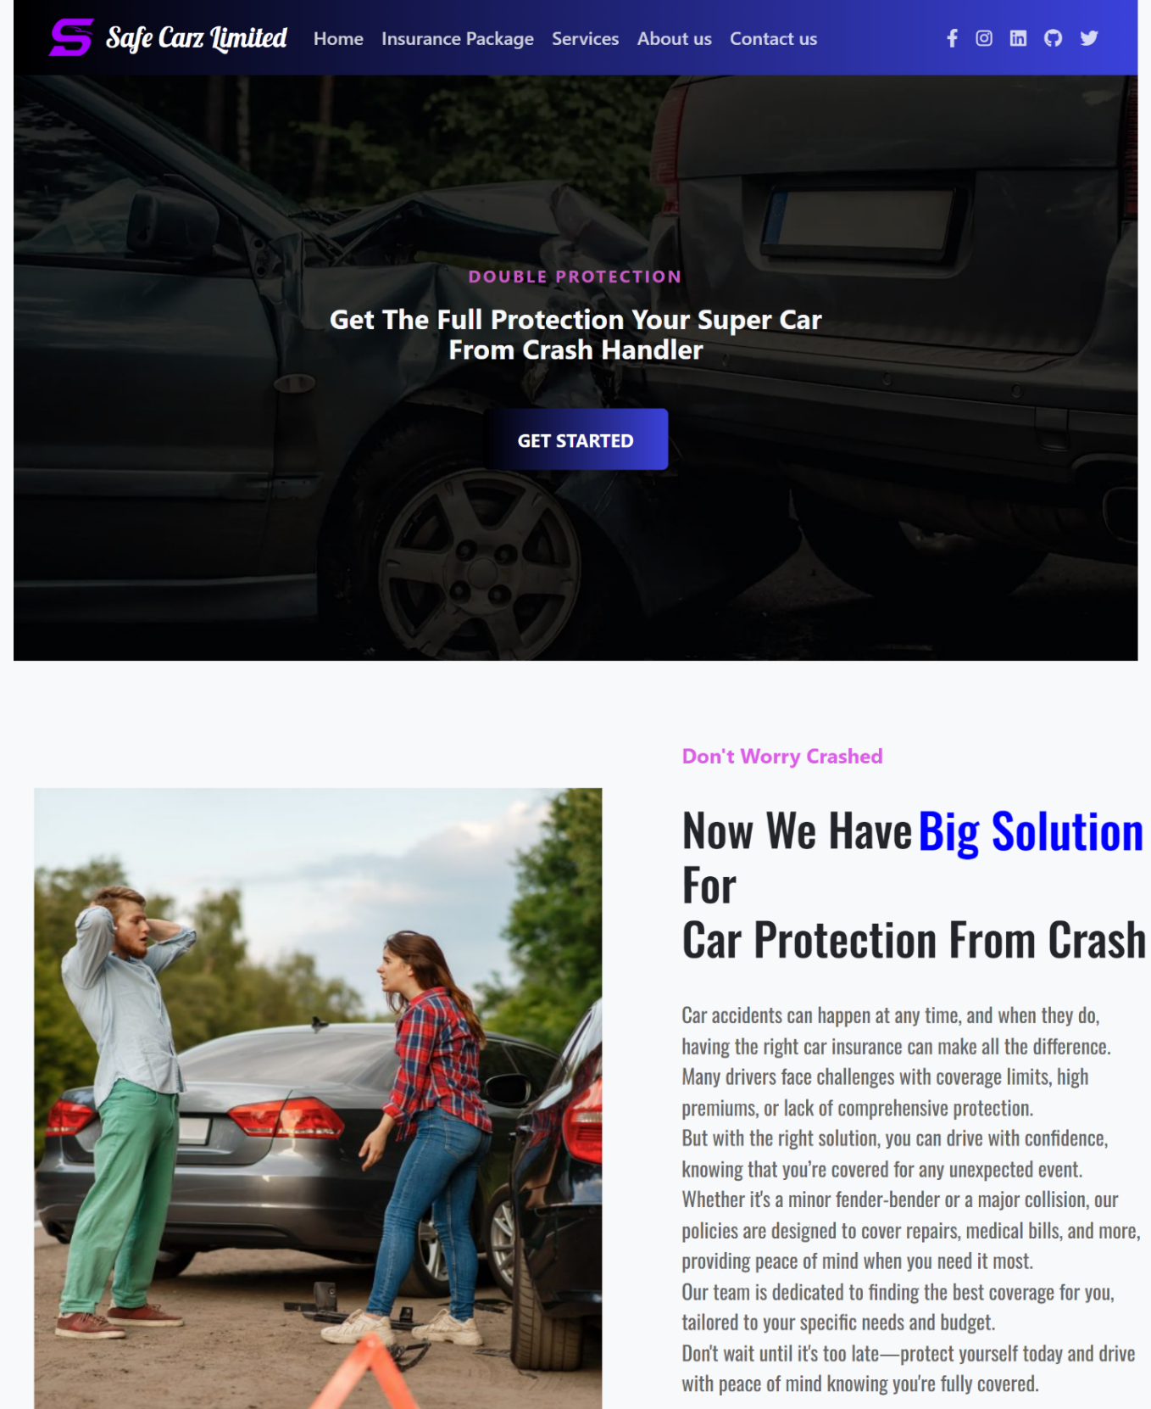

***CODE OF HOME PAGE***

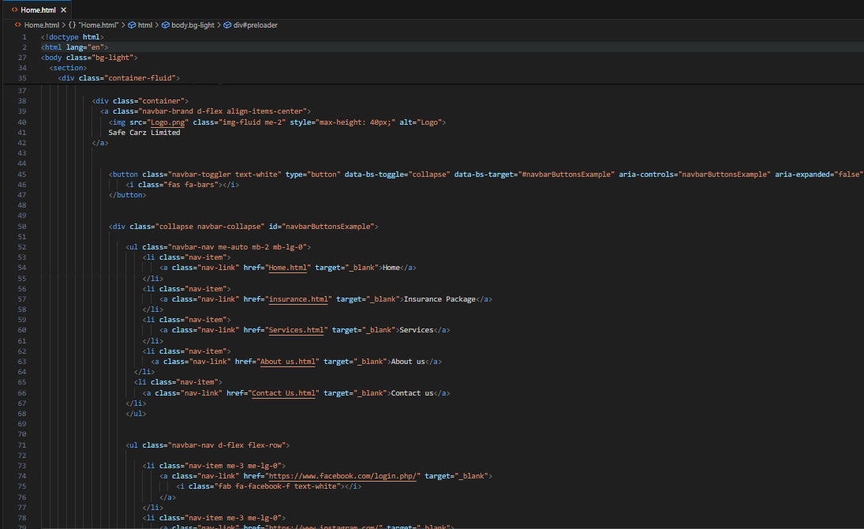

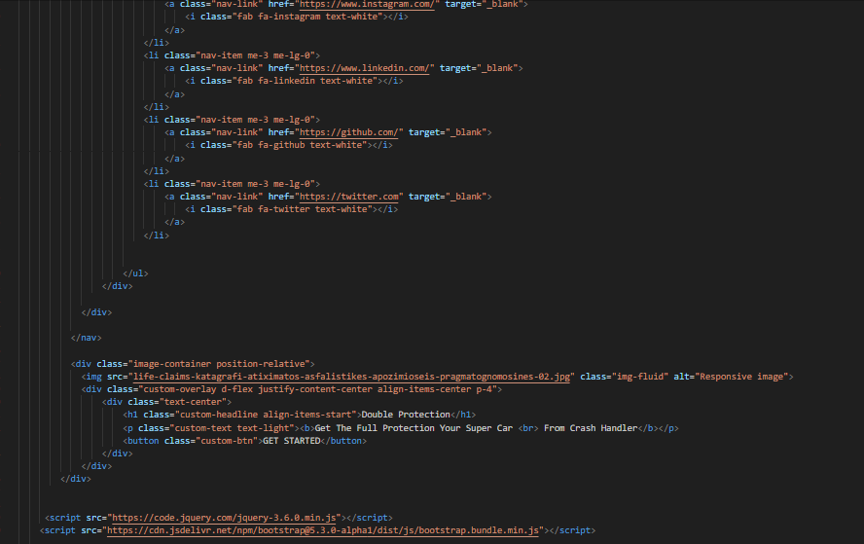

***NAVBAR***



***CODE***

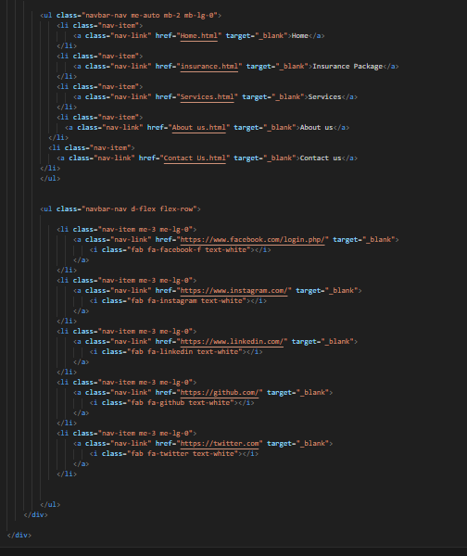

***Insurance package***



***Code***

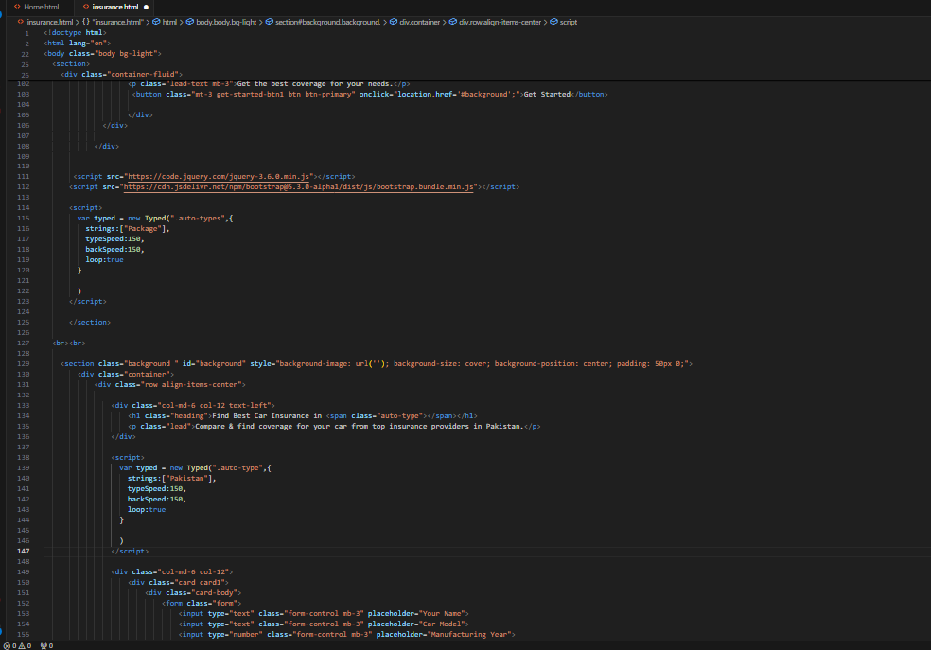

***Service***



***Code***



***About Us***

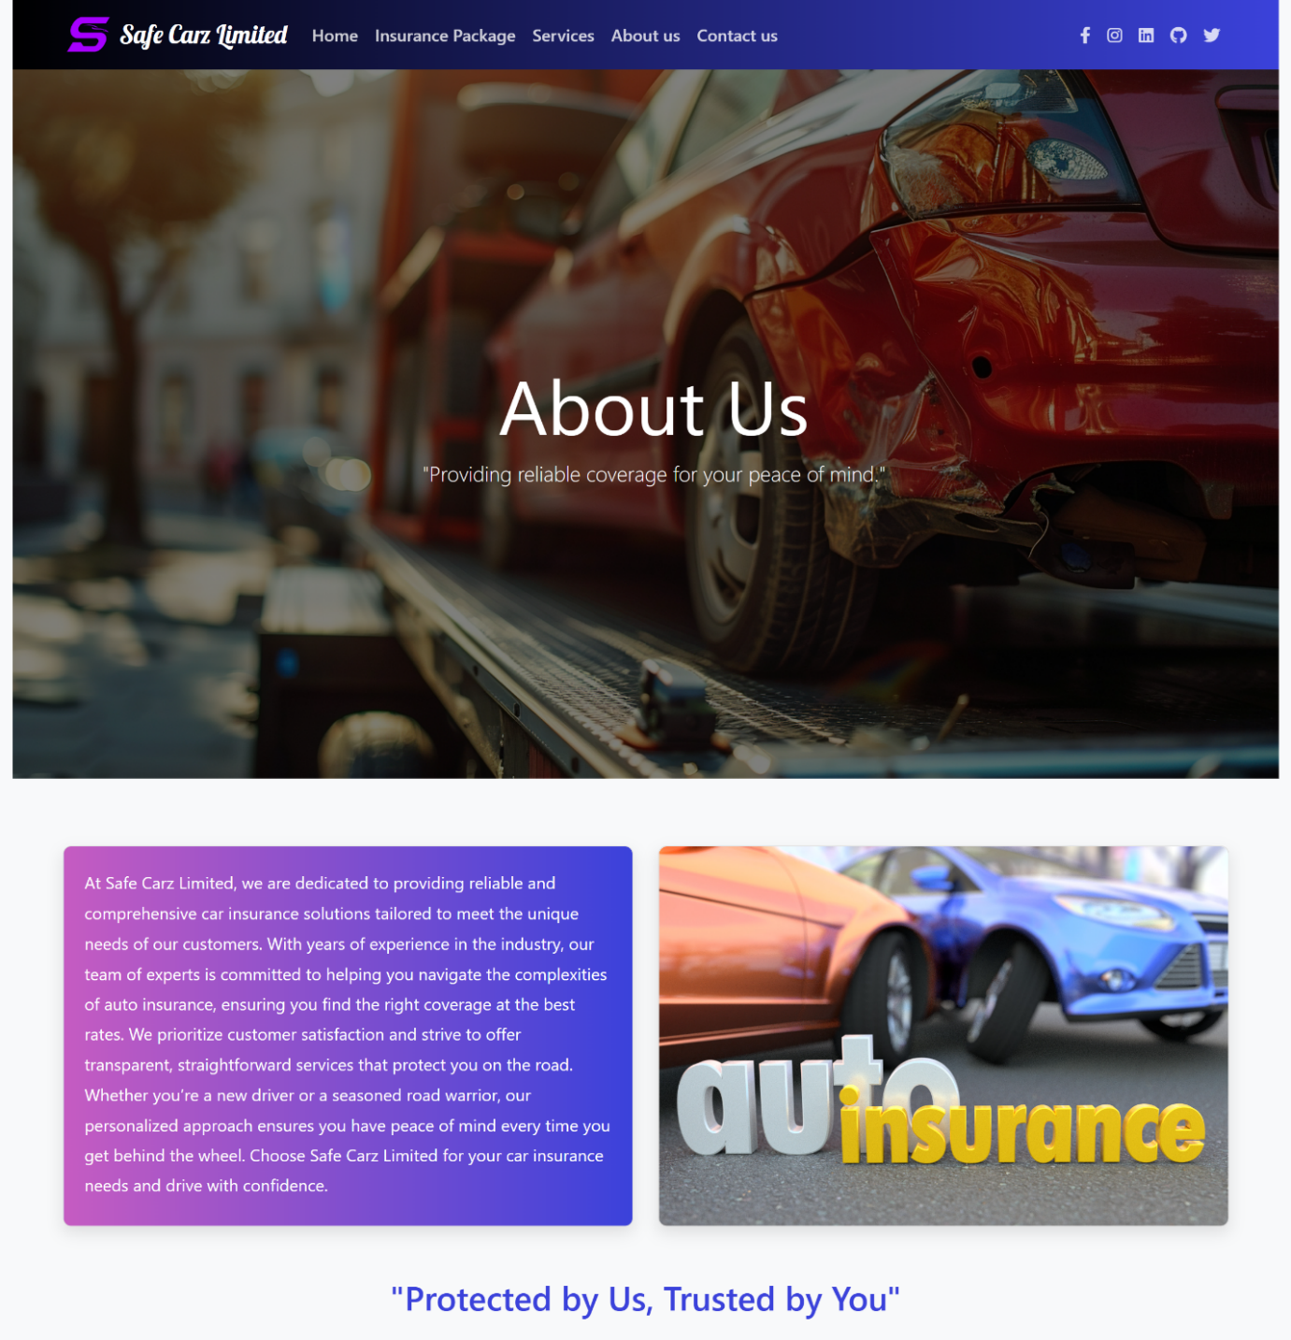

***code***

